1. 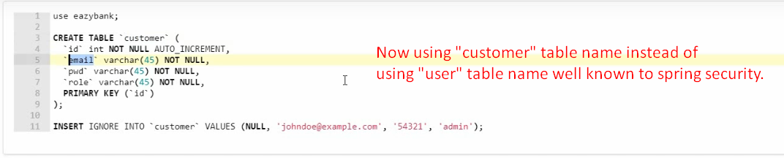
2. 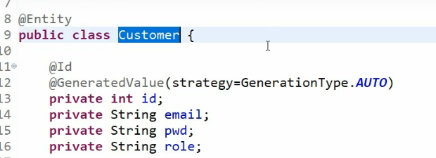
3. 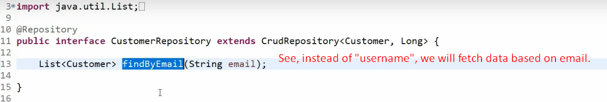
4. **NOTE**: Instead of providing “UserDetails”, we have provided “Customer” which Spring Security doesn’t understand.  
   Spring Security understands only UserDetails objects.  
   So, let’s create UserDetails.
5. 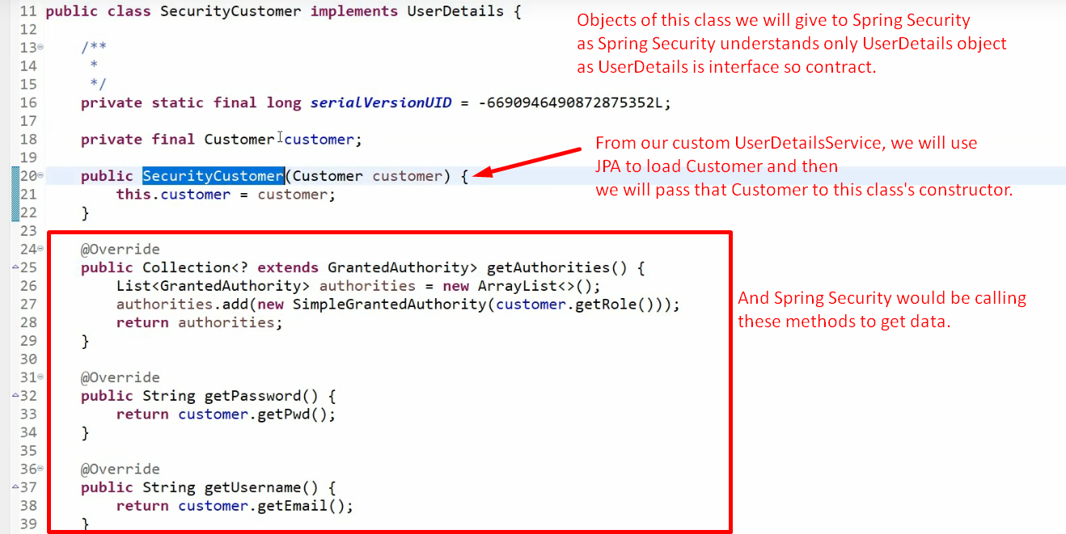
6. 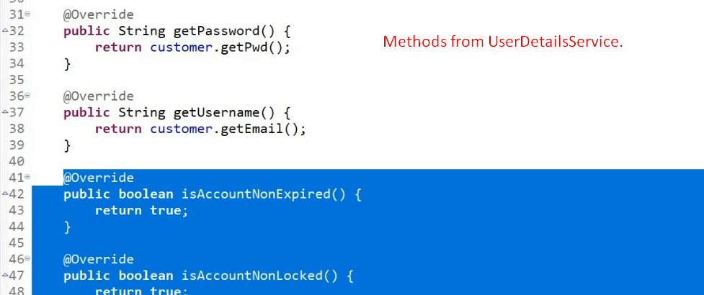
7. 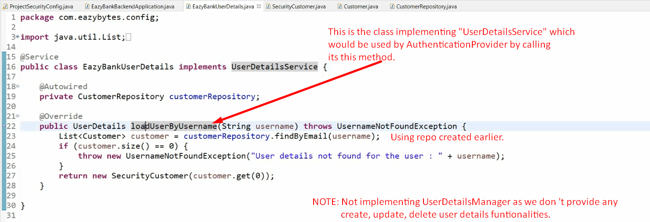  
   Note the annotation @Service at EazyBankUserDetails so its bean would be registered and Spring would know that it has to use this bean to fetch UserDetails.  
     
     
     
   